Lab 6

Linear Regression

Introduction
The goal of this lab is to perform linear regression on housing file (housing.csv)

Each question must be answered, and all the relevant screenshots must be included with your name (python code and Output).

Submit both the Word document and python file

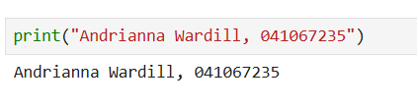
- Perform EDA on the housing.csv file.
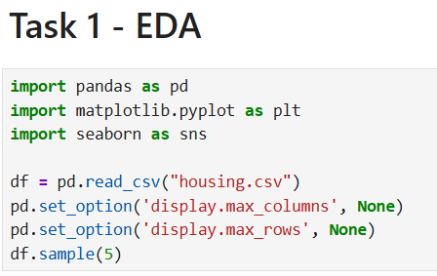
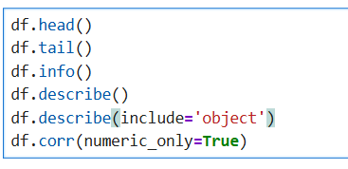
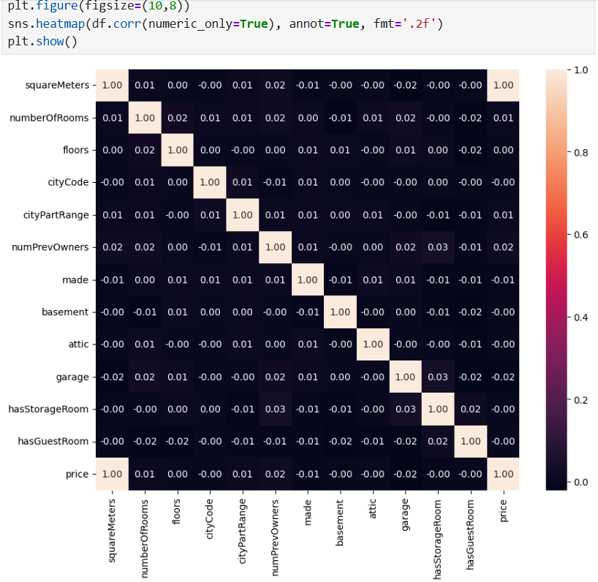
- Answer the following questions:

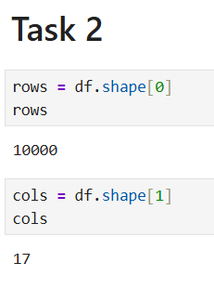
  - Number of instances? 10000
  - Number of attributes? 17

- Perform Data Cleaning and Feature Engineering as per requirements. Also, all columns should be numeric. If you have any other types, convert them to the right type
  - Required conversions (add rows as required):
Column to be converted | Required Conversion/Preparation
- hasYard  - hasPool  - isNewBuilt  - hasStormProector | - Set Yes to 1 and No to 0  - Set Yes to 1 and No to 0  - Set Yes to 1 and No to 0  - Set Yes to 1 and No to 0
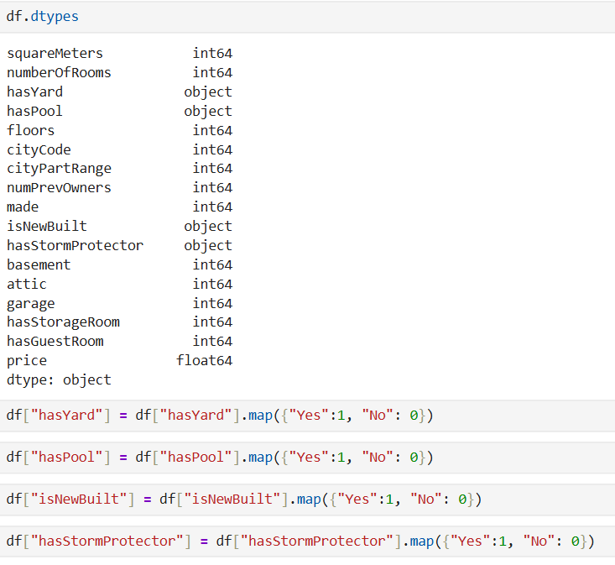
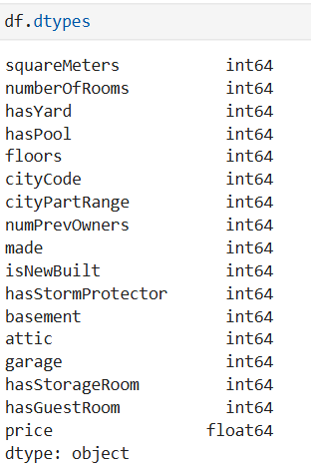
  - Feature Engineering

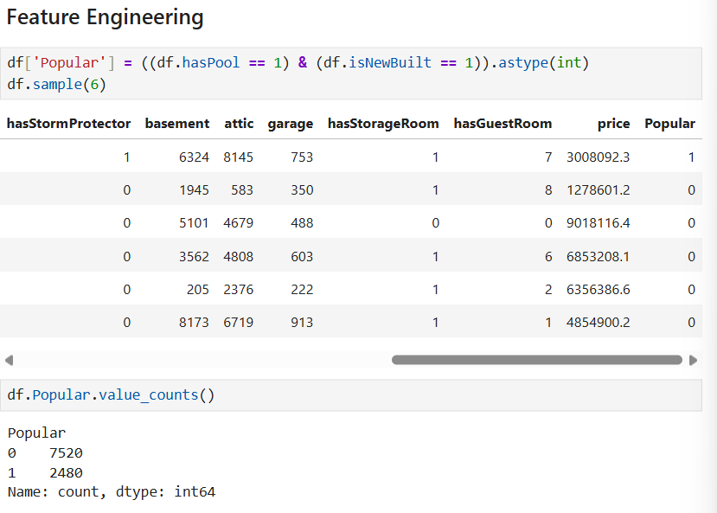
  - Interaction Features
    - Number of non-guest rooms: num of rooms – has guest rooms
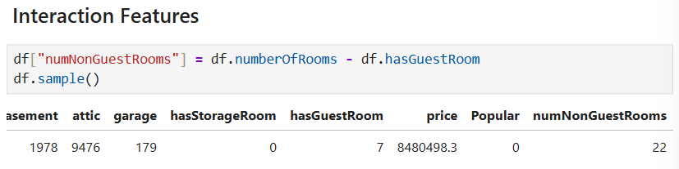
    - Square meters – (basement + attic + garage)
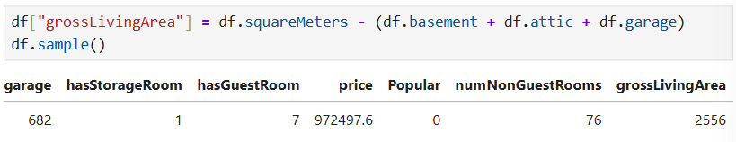
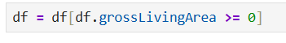
    - House Age = 2026 - made
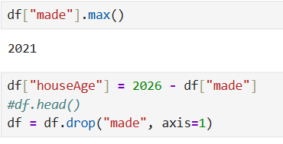
  - Save to CSV
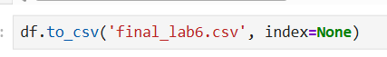
- Apply Linear regression model. You must set the class column.
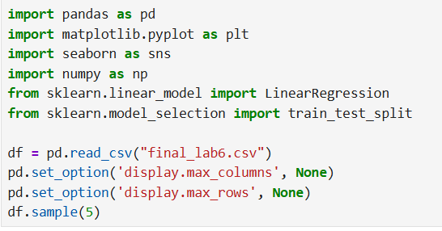
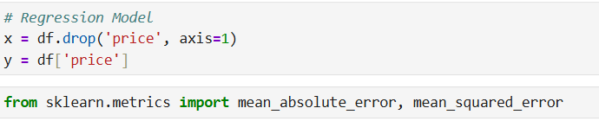
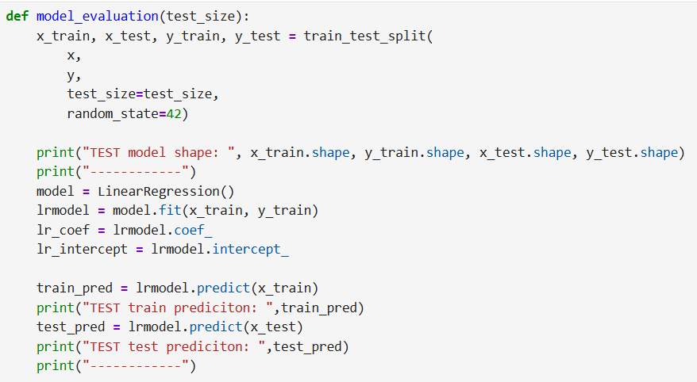
- Compute MAE and RMSE for both Train and test set. Evaluate the performance of dataset with multiple Test / Train splits (80:20, 70:30, 85:15). Which one has the best performance.
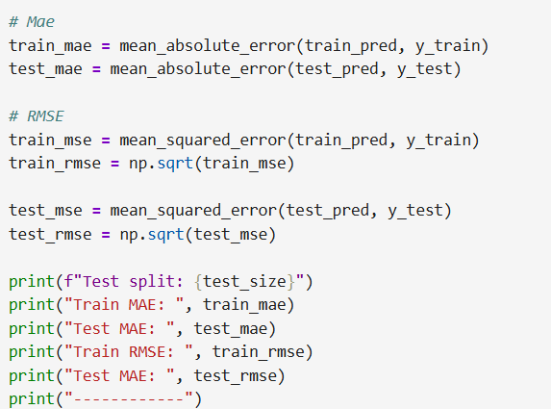
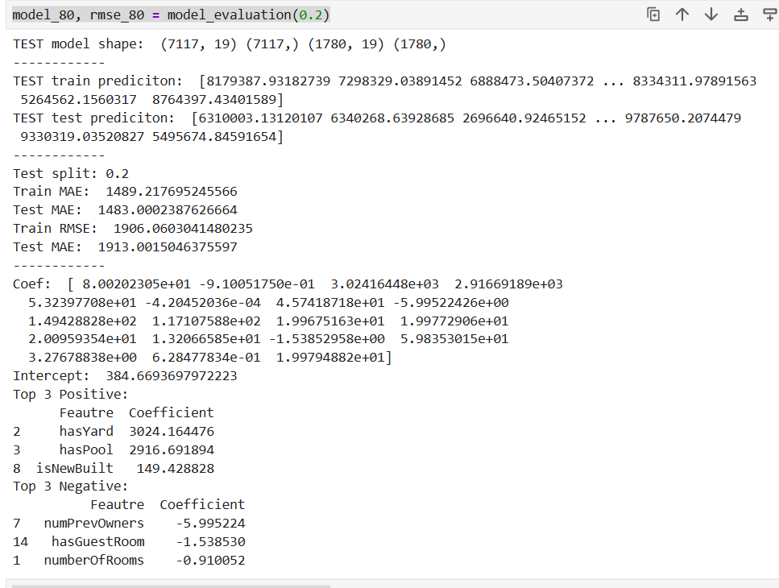
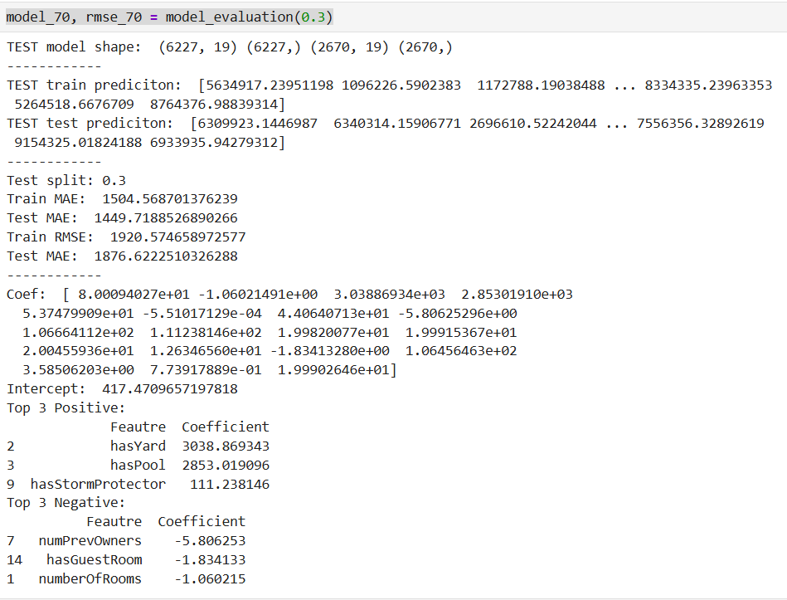
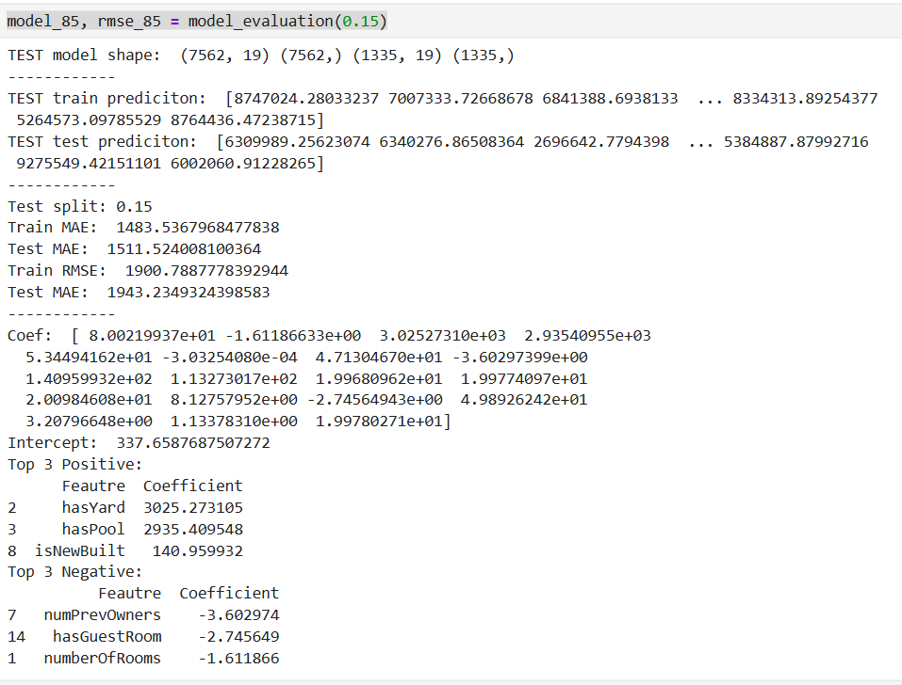

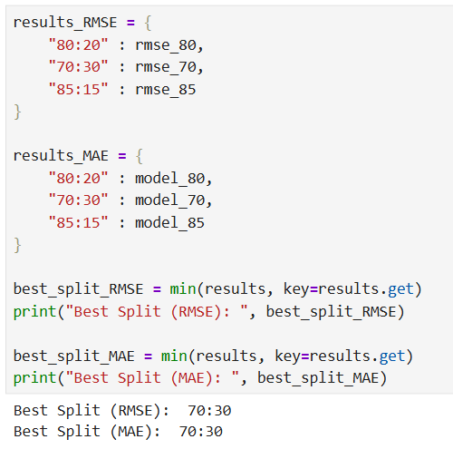

- List 3 highest positive & negative influential factors along with their coefficients:

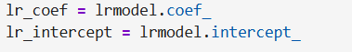
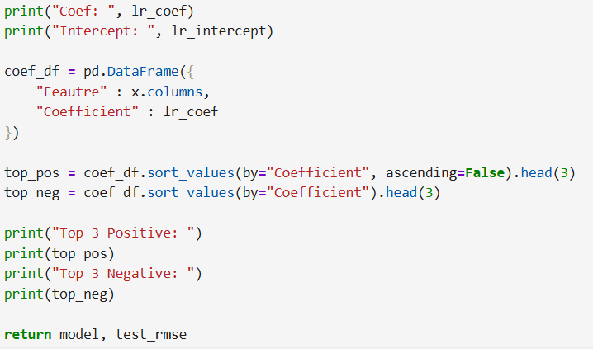

- Outputs for the Coef for each model are included in the screenshots from Question 5

